LAKE MASPENOCK WEED MANAGEMENT AND CONTROL ADVISORY GROUP
HOPKINTON MA 10748

MARCH 24, 2016 MINUTES

In attendance;
John Westerling, Dept. of Public Works
Jeff Barnes, Conservation Commission
Eric Sonnet, Parks & Rec. Dept.
David Mitchell, Consultant
Jamie Goncalves, At Large
Cynthia Esthimer, At Large
Drew Logan, At Large

- Call to order byJamie G at 7 pm. Minutes from our March 8, 2016 meeting were unanimously approved without changes.
- Jamie brought suggestions for zoning of the lake so that we could prioritize areas for treatment as well as look at options for each zone. The committee spent significant time on this activity.
  - We identified and prioritized 9 separate zones
  - Prioritization was based upon:
    - High recreational use (swimming, boating, fishing, etc)
    - Residential waterfront
    - Weed density
  - David reinforced the need to maintain a healthy balance of aquatic vegetation in the lake, ie“don’t touch where we don’t need to”
- Several maps where shared with the group including the aerial satellite view during the winter extended drawdown, a watershed GIS map from mass.gov Oliver, and maps with weed density from previous surveys.
- High priority areas are: 3,2,1,4 - see map below
- Preliminary feasible options for each zone were determined to be:
  - Zone 3 – benthic barrier (north & south strips), hand pulling & disposal, spot herbicides, diver assisted suction harvesting (DASH)
  - Zones 1, 2 – mechanical harvesting, herbicide
  - Zone 4 – mechanical harvesting, hand pulling & disposal, spot herbicides, DASH
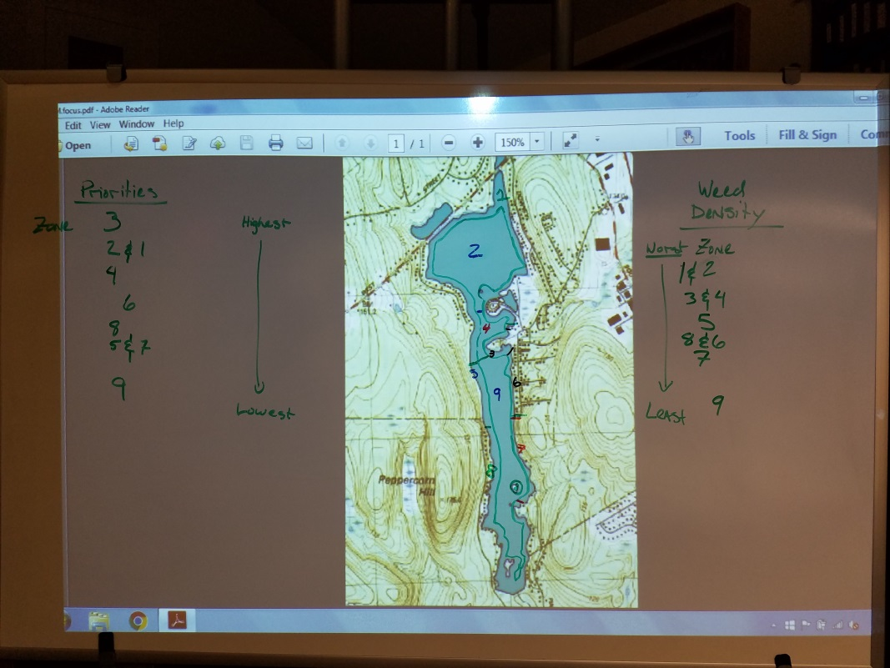

- Jeff reported out on conversations with other members of ConCom relating to developing pre-approved guidelines that residents could follow to treat the weeds on their own (presumably on waterfront adjacent to their property) At first blush, this does not look promising and may require homeowners to file a separate NOI for each intended action. David mentioned that Sturbridge may have been successful implementing such a plan and Jeff will look into it.
- David provided a detailed update on dredging. Due diligence for this method was performed for our lake in 1987 and David cited several points from within this report. Extensive permitting, timeframes and regulations make this an unfeasible option. Would estimate it to be a $10m project over several years. Interviews with Milford Pond officials were also cited as references.
- Eric suggested we develop a Vision Statement on the value of the lake and why the town should care.
- David reinforced the need for comprehensive monitoring as part of the overall plan. Although the LMPA does water quality testing, we should assess whether more tests should be done as well as expand the monitoring to include weed density and type by location.
- David shared additional examples of comprehensive Aquatic Weed Management Plans from other lakes. The committee agreed that this will need to be developed for Lake Maspenock.
- Our next meeting will be focused on developing costs of treatment options for each zone as well as finalizing the recommended plan for this year and beyond. Dates for public forum and selectman’s meeting will be decided.

- Upcoming Committee schedule
  - March 31, 7-9 pm
  - Open forum report out, tbd
  - Selectman’s meeting report out, tbd

- Action items:
  - John W. to identify square footage for each zone.
  - Jeff to work with Con Com on developing guidelines/approvals for what residents could do on their own to control weeds, eg, hand pulling. Contact Lake Association in Sturbridge to understand what they did.
  - Jeff to continue to add to a comparative table of herbicide options
  - Cynthia to begin work on a vision statement.
  - David to provide cost/sqft of treatment options identified for each zone.

Meeting adjourned at 9:05 pm.
Minutes respectfully submitted by Drew Logan

