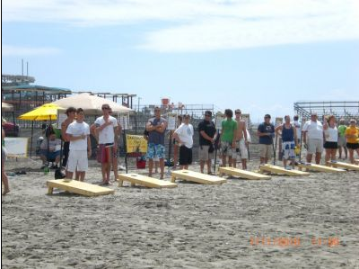
SAVE THE DATE!!
Inaugural LMPA Corn Hole Tournament and Fundraiser
Saturday, July 30th 2016
Start time: 12:00 pm
- Limit 20 x 2-person teams, open only to LMPA members initially.
- Double elimination tournament – you are guaranteed at least 2 games
- $20/person entry fee. Cash prizes and trophies to the top finishers.
- There will be at least 6 houses around the lake where games will be played. You will need to move to different locations as you advance. There will be a few pontoons available for transportation if you need it!
- After the finals, there will be a potluck dinner with the LMPA providing burgers and dogs.
- More details to follow, including official rules and how to register

We need Corn Hole sets! If anyone has access to a set of corn hole boards and beanbags, please email the LMPA.org@verizon.net.
