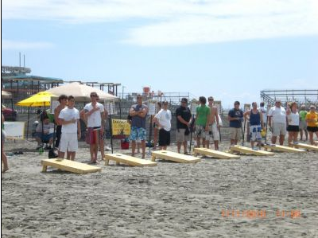
Registration open!!
Inaugural LMPA Cornhole Tournament and Fundraiser
Saturday 12-5 pm, July 30th 2016

- Limited to 20 x 2-person teams, open only to LMPA members initially. Register now to secure your spot!
- Double elimination tournament – you are guaranteed at least 2 games
- $20/person entry fee. Cash prizes and trophies to the top finishers. Payment due at sign up.
- There will be 6 houses around the lake where games will be played. You will need to move to different locations as you advance. There will be a few pontoons available for transportation if you need it!
- After the finals, there will be a potluck dinner with the LMPA providing burgers and dogs.
2 options to sign up:
- Online via PayPal or Credit Card : www.LMPA.org/membership scroll down to “Cornhole Tournament” or:
- Send registration form (below) and check for $20 ($40 for a team of 2) to “LMPA”
  - c/o Tina Macconnell, 6 Downey Street, Hopkinton, MA 01748
We need Cornhole sets! If anyone has access to a set of cornhole boards and beanbags please email the LMPA.org@verizon.net.

Inaugural LMPA Cornhole Tournament and Fundraiser
Saturday, July 30th, 2016

Name: ___________________________________________________________
Address: _________________________________________________________
Email: ____________________________________________________________
Cell phone: ________________________________________________________

Do you have a partner? y/n _____ name of partner _______________________
(if you do not have a partner, we will pair you up with another single)

Team Name:_________________________________________________________

Send this completed form along with a check for $20 ($40 for a team of 2) to “LMPA”
- c/o Tina Macconnell, 6 Downey Street, Hopkinton, MA 01748

