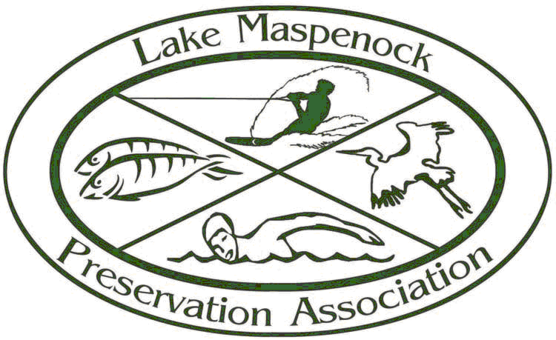

Lake Maspenock Preservation Association
Website: www.lmpa.org Email: lmpa.org@verizon.net

TIME LINE NARRATIVE

The issue of controlling invasive and problematic weed growth in Lake Maspenock has been studied and debated for over a decade. In 2009, the LMPA teamed with the Hopkinton DPW to formalize the annual draw down plan of Lake Maspenock. The request to formalize the plan was made by the Hopkinton Conservation Commission. At that time, the LMPA advocated to include an aquatic plant control method on the Notice of Intent to be filed. Since the requested method was directly related to the requested task, it seemed to be the perfect opportunity. The LMPA, after much research, had chosen the extensive draw down every 3rd year as the aquatic plant control method to pursue. The normal draw down is about 4 feet, while the more extensive draw down is a reduction of up to 8 feet. The more extensive draw down would expose more of the lake bed to freezing winter temperatures which kill the root systems of the invasive weeds. Native aquatic growth reproduces by both seed and root growth so is not eliminated by this method. The invasive weeds are targeted, leaving the native plants in place. As part of the plan the LMPA is required to conduct a biological survey of the lake the summer following each extensive draw down. This is intended to assess the effectiveness of the method in controlling the invasive weeds, and to detect any unintended negative side effects. No town funds are requested or used to conduct the biological surveys; all costs are funded by the LMPA. The Hopkinton Conservation Commission approved the draw down plan which included the more extensive draw downs.

The survey following the first extensive draw down, (Approx. 7’ reduction), in the fall/winter of 2010/2011, confirmed the anecdotal reports received from lake area residents. The density of the weed growth the summer following that draw down was dramatically reduced. No adverse effects to other life forms in the lake were detected. The density of milfoil and fanwort had been reduced to non-problematic levels. As is common in nature, the void opened up by the reduced levels of those two weeds, was filled by other weed growth. The 2nd summer after the first extensive draw down an increase, to problematic levels, was seen in the large leaf pond weed. This plant, which is native to the area, reproduces by both root growth and seed, so the draw down method has very limited success in controlling it. A request was made to the Hopkinton Conservation Commission to conduct another extensive draw down the fall winter of 2013/2014. The hope was that some reduction in this weed could be accomplished. The draw down plan has very strict protocol, which must be followed per the ‘order of conditions’ issued with the permit. All draw downs are subject to restrictions as to when reductions can begin and when they must cease. In addition, the maximum rate of reduction per day is strictly controlled. The Hopkinton DPW administers and controls the draw down of the lake each year. One of the major limitations to the draw down method is that it is subject to the whims of the weather. If heavy rains off-set reduction levels or if no freezing temperatures are experienced when the lake bed is exposed, the draw down will have little or no effect on the weed growth. That scenario took place during the 2nd extensive draw down effort. Abundant fall rains off-set the reductions and mild weather occurred when the maximum reduction level for that year was reached. A reduction of only about 5 feet was reached that year because of the amount of rain in the fall. This is only 1 foot more than a normal draw down year. No relief from the large leaf pond weed was realized, and the summer of 2014 showed extreme growth of the weed in some areas of the lake. The density of the growth made the lake un-usable in those areas.

Early in the fall of 2014, requests were made to all LMPA members to serve on a weed management study committee being formed. Absolutely no restrictions were placed on who could or could not serve on the committee, other than that they be members of the LMPA. This committee was tasked with researching and assessing the viability of all weed control methods. They were to report back to the LMPA executive board and had no authority to act on behalf of the LMPA. Extensive research was done, including reaching out to other lake associations, to seek information on how they managed aquatic weed growth in their lakes. The LMPA officers and executive board members reviewed and evaluated the recommendations of the committee. The recommendation of the committee was that the application of herbicides was the most viable method to control the large leaf pond weed. The executive board agreed with that assessment and voted unanimously to make that recommendation to the membership. It was decided that a full membership meeting would be held, and to ask for a vote from the membership, to confirm that they were in agreement with the LMPA executive board vote. The membership would make the final decision. Multiple notices of the meeting were issued in December. The subject matter, and that a vote would be taken, were clearly indicated. The meeting was held January 8, 2015 in the Hopkinton High School cafeteria. 64 members of the association were in attendance, far in excess of the 20 member quorum required in our bylaws. A presentation was made, members were allowed to write down questions and submit them to be answered. This procedure was followed because the time for access to the room was very limited. The result of a vote taken that evening was overwhelmingly in favor of seeking all required approvals and permits required by the Town and State, to apply herbicides in an effort to control the excessive aquatic weed growth. Through discussions with town officials, the Hopkinton DPW sponsored a Notice of Intent for the plan. A public hearing was held by the Hopkinton Conservation Commission, on March 9, 2015, after all required notifications and postings were completed. The plan had previously been reviewed by the Conservation Commissions in the Towns of Milford and Upton. Both Towns deferred to the Hopkinton Commission after their reviews. This hearing was open to all Hopkinton residents. Only 3 residents in attendance were opposed, all others were in support of the plan. The Hopkinton Conservation Commission voted unanimously to approve the plan.

